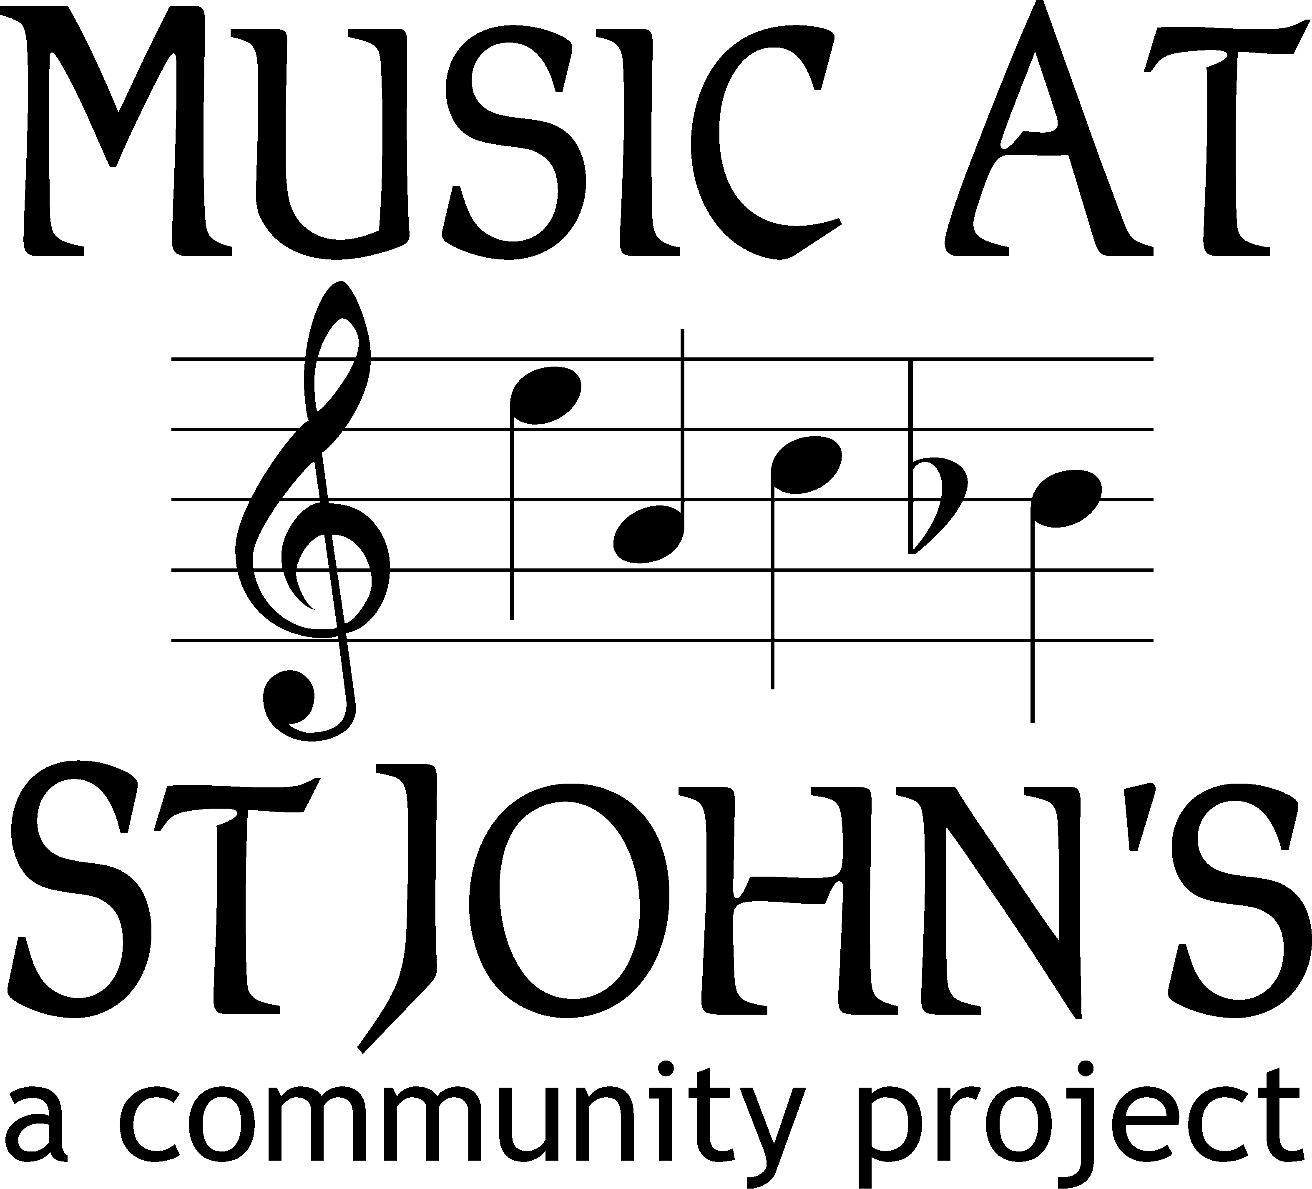

MUSIC AT ST JOHN’S BOARD MEETING ON WEDNESDAY 8 MAY 2019 AT 8PM IN THE QUIET ROOM AT ST JOHN’S CHURCH

AGENDA
- Opening formalities
- Opening prayer (Vicar)
- Apologies (Acting Chair/Richard)
- Notice of items to be raised under Any Other Business (Acting Chair)

- Approval of the minutes of the MASJ Board meeting held on 13 March 2019
- Approved minutes to be signed by the Acting Chair and formally filed (Board Secretary)

- Appointment to the Board
- Appointment of Nyree O’Brian as a member of the Board (Acting Chair).
- Nomination paperwork to be completed (Board Secretary)

- Matters arising from last Board meeting
- Review action points (Acting Chair)
- Any other matters arising from these minutes that are not covered elsewhere on this agenda (Acting Chair)

- MASJ communications and new website
- Progress on new website (Job)
- MASJ Facebook page (Richard)
- “Full Score” – sitrep on latest edition of “Full Score” (Nicholas)
- Overall responsibility for publicity (Acting Chair)

- Music Bursary
- Report back from Music Bursary Committee (Nicholas)
- Possible re-launch of Music Bursary (Bursary Committee).
- Promotion of Music Bursary scheme to local schools (flyer in DMS leaflet) and at Music Festival events (mention in introduction?) (Acting Chair)

- Treasurer’s Report & Fundraising Position
- Report on financial situation of MASJ (Catherine)
- Current ability of MASJ to make disbursements to the Parish and fund the bursary scheme (Catherine)

- Event Fundraising
- Past event – Alexander Ardakov concert on 16 March 2019. Wash-up (Acting Chair)

- Music Festival
- Arrangements for 10-12 May 2019 Music Festival (Acting Chair)
- Friday lunchtime Concert
- Saturday morning – Dacorum Music School
- Saturday evening – Dacorum Youth Orchestra
- Sunday evening – Choral Evensong
- General – programmes, publicity, box office, refreshments, volunteers (who does what)

- Lunchtime Concerts
- Next series of lunchtime concerts (Acting Chair)

- Percentage Club
- General position (on behalf of Mark)

- Educational events
- Sitrep including UniSong and WOOFYT (Nyree)
- Risk assessments over educational events (Nyree/Acting Chair)

- P C C
- Report back of any items of interest to MASJ discussed at the last PCC meeting (Acting Chair)
- Request from the Director of Music that MASJ make a contribution to the cost of reinforcing the choir over Easter (Acting Chair)

- Future meetings
- The next Board meeting will be on Wednesday 10 July 2019. Subsequent Board meetings will be held on Wednesday 11 September 2019 and Wednesday 13 November 2019. The 2019 AGM will be held on Friday 4 October 2019 following the Lunchtime Concert.

- Any other business.
- As notified at the start of the meeting (Acting Chair)

