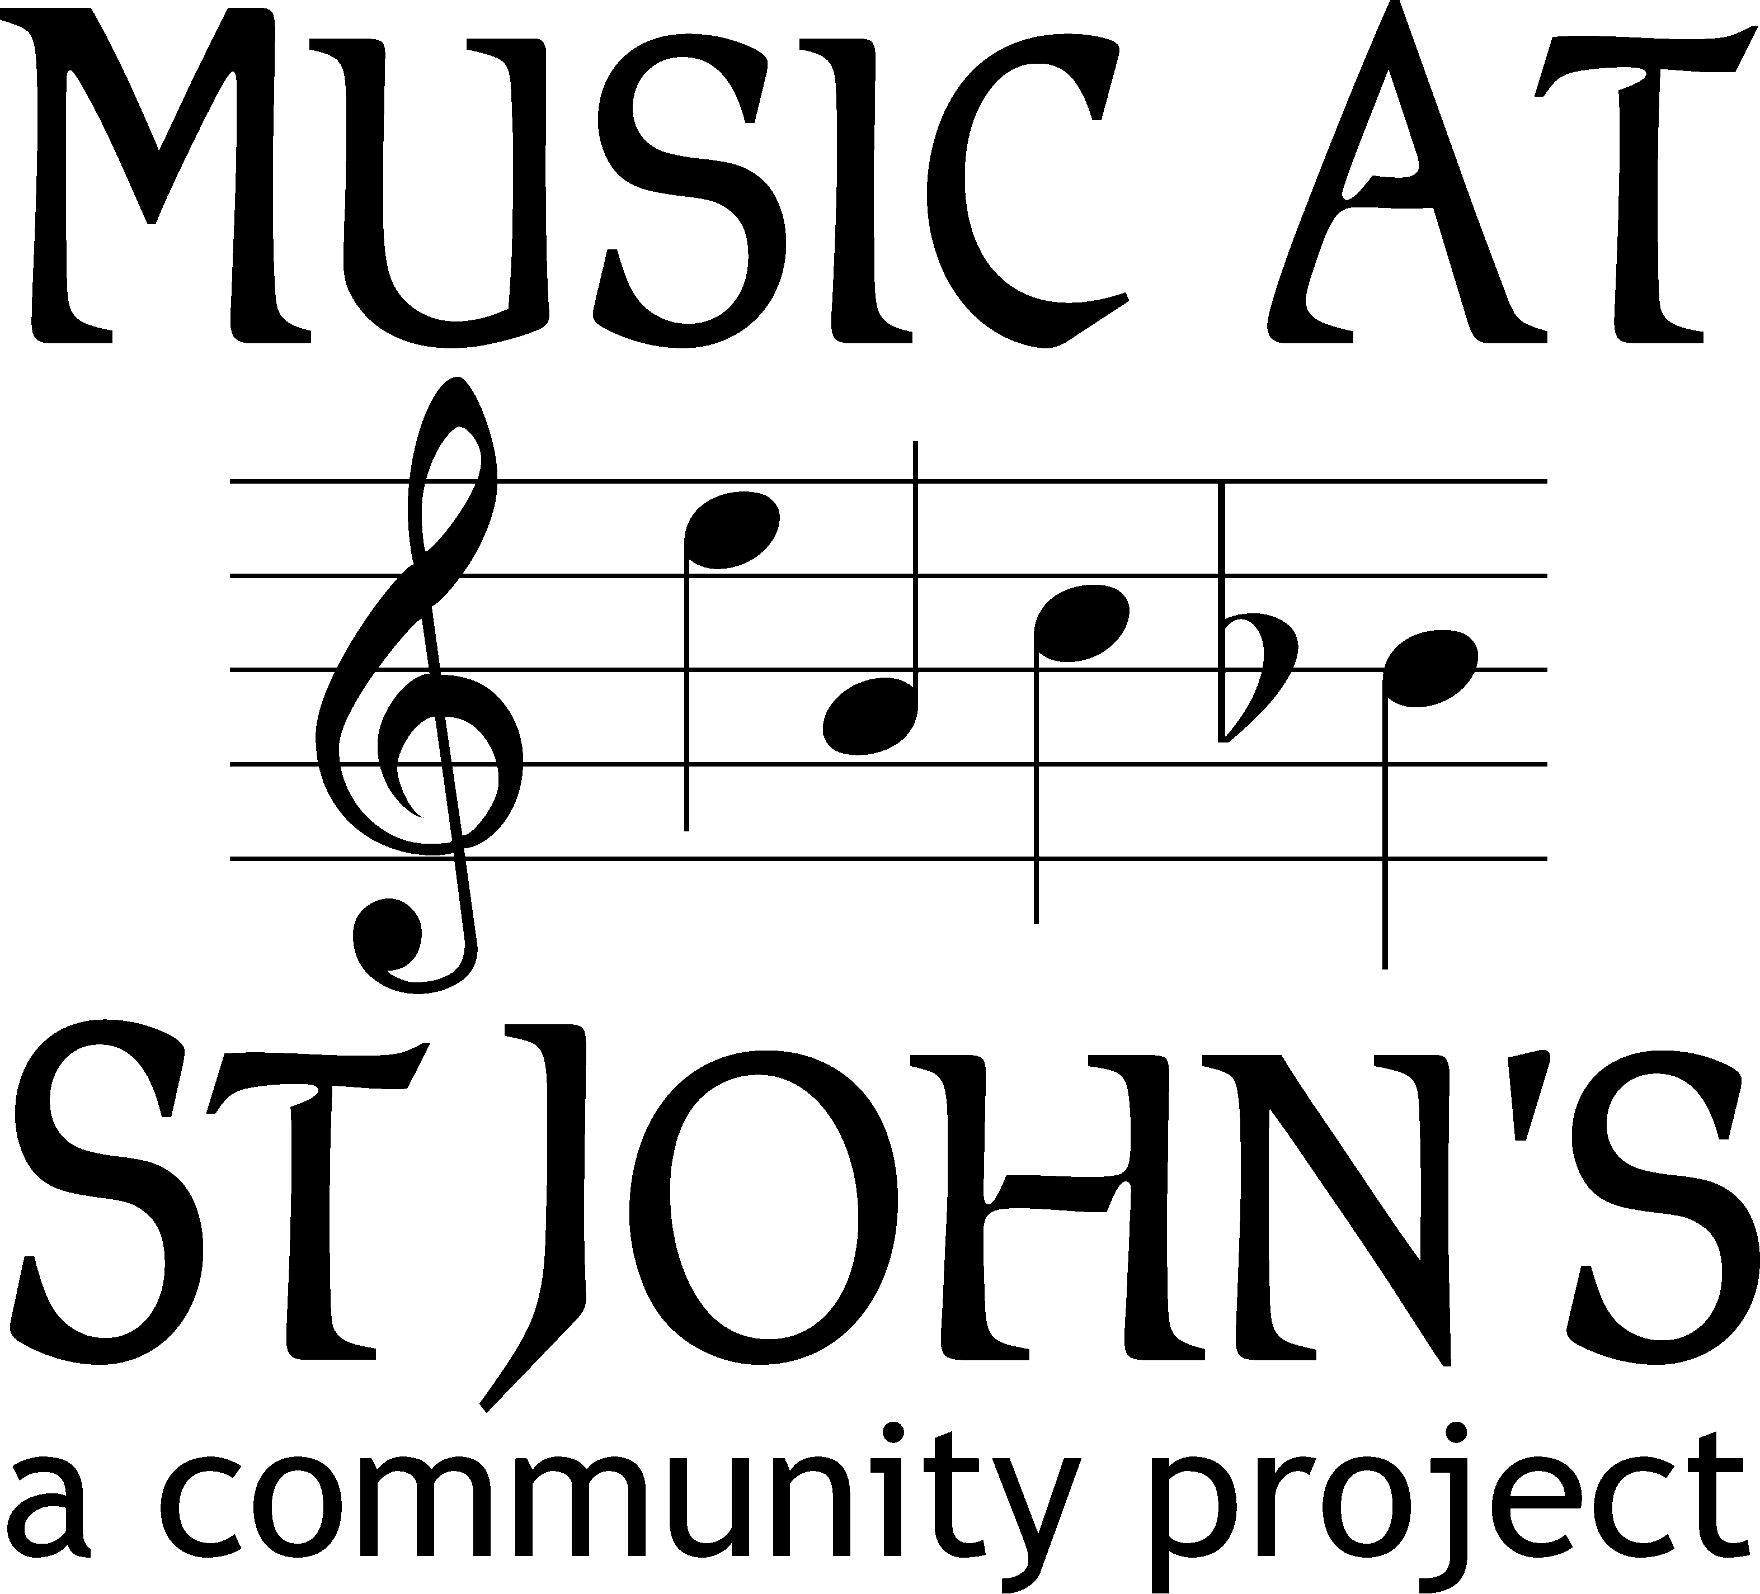

LUNCHTIME CONCERTS

at St John’s Church, Station Road, Boxmoor, Hemel Hempstead, HP1 1JY

Fridays at 12:30pm

Autumn 2022 series

Date Artiste(s)

16 September Folk songs with Christine Bennett and her guitar

23 September Revisiting Highlights of recent recorded concerts

30 September Nicholas King organ – 20th Anniversary Recital!

7 October Arwen Newband violin and Anna Le Hair piano

14 October Charles Sewart violin and Debbie Shah piano

21 October Catherine Underhill oboe and Kerry Waller piano

28 October Mark Wilson countertenor

4 November Star Flutes flute quintet

ADMISSION BY DONATION (suggested donation £3)

Light lunch available (£2 per head) after each concert.

Net proceeds from all of the Friday lunchtime concerts will be used to support
the charitable aims of Music at St John’s:
promoting music in the church and the local community,
including provision of bursaries for local young musicians.
(see www.masj.org.uk for details)

If you would like to be added to our mailing list (to be kept informed of events)
please send your name and email address to masj@stjohnsboxmoor.org.uk

Music at St John’s Ltd. (registered charity number 1119580)

LUNCHTIME CONCERTS

at St John’s Church, Station Road, Boxmoor, Hemel Hempstead, HP1 1JY

Fridays at 12:30pm

Autumn 2022 series

Date Artiste(s)

16 September Folk songs with Christine Bennett and her guitar

23 September Revisiting Highlights of recent recorded concerts

30 September Nicholas King organ – 20th Anniversary Recital!

7 October Arwen Newband violin and Anna Le Hair piano

14 October Charles Sewart violin and Debbie Shah piano

21 October Catherine Underhill oboe and Kerry Waller piano

28 October Mark Wilson countertenor

4 November Star Flutes flute quintet

ADMISSION BY DONATION (suggested donation £3)

Light lunch available (£2 per head) after each concert.

Net proceeds from all of the Friday lunchtime concerts will be used to support
the charitable aims of Music at St John’s:
promoting music in the church and the local community,
including provision of bursaries for local young musicians.
(see www.masj.org.uk for details)

If you would like to be added to our mailing list (to be kept informed of events)
please send your name and email address to masj@stjohnsboxmoor.org.uk

Music at St John’s Ltd. (registered charity number 1119580)

